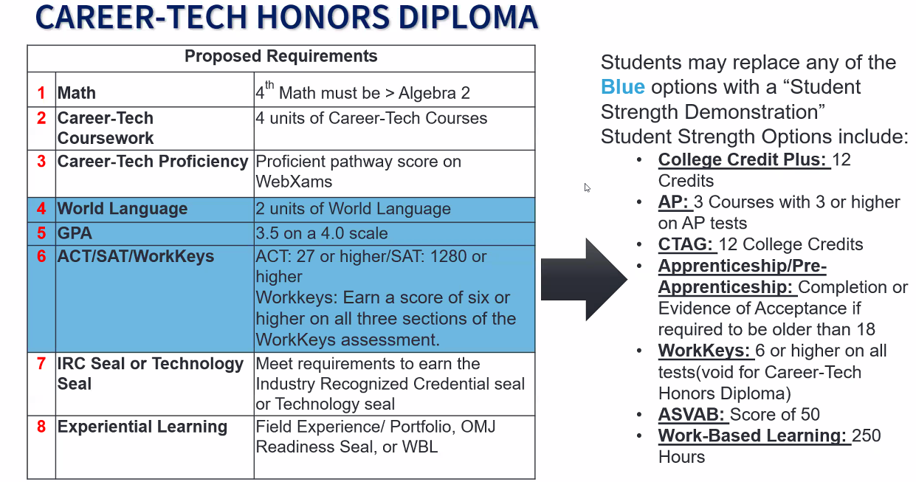

**Class of 2026 and Beyond**